Each annual report of IISS The Military Balance has a detailed section about each country’s military capabilities including its military deployment. The title of this subsection over years ( “Forces Abroad”, “Deployment”, etc)

For instance, the military deployment of Romania in 2022.

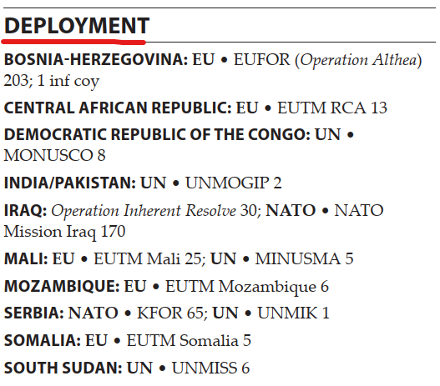

The data collection included two stages: manual and automated.

At first one coders had to divide the information about deployment on following variables:

**ccode1**

The country’s COW (Correlates of War) digital code, that deploys troops

In this case it will be Romanian code - “360”

**abbrev1**

The country’s COW (Correlates of War) three-letters abbreviation , that deploys troops

Romanian abbreviation - “ROM”

**CountryName1**

The country’s deploying troops name according to IISS Military Balance

For this case - “Romania”

**ccode2**

The country’s COW (Correlates of War) digital code, that hosts troops

**abbrev2**

The country’s COW (Correlates of War) three-letters abbreviation , that hosts troops

For Iraq it will be “IRQ”

**CountryName2**

The country’s hosting troops name according to IISS Military Balance

**year**

The year of the dyad.

As it was noted above, the example is for 2022.

**Presence_mentioned_MB**

Is interaction between a couple of countries mentioned in the IISS Military Balance? (the value "yes" - "1" is automatically entered)

**Border territories between two countries**

Under peacekeeping mandate troops could be deployed in order to monitor boundary integrity and ceasefire, thus troops are located on the border between two countries. In this case coders assigned 1 to the variable and 0 otherwise.

For instance, 1 will be for Romania - India/Pakistan 2022 dyad, and 0 for others.

**Troops**

The total number of deployed military personnel in the dyad

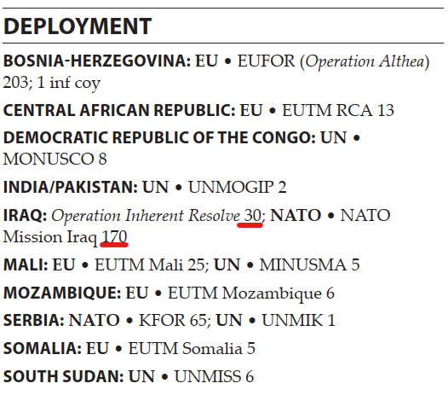

For Romania - Iraq 2022 dyad , the total number of troops that will 170+30=200

**Additional_Information**

All the information that follows after the country hosting troops.

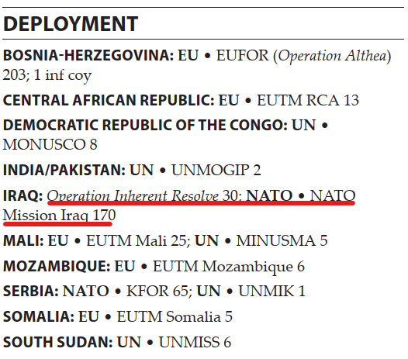

For Romania - Iraq 2022 dyad it will be “IRAQ: Operation Inherent Resolve 30; NATO • NATO Mission Iraq 170”.

In the automated stage one of the coders searched for operation names in the variable Additional_Information. In our data there could be six operations for one dyad, if there are less or no operation at all, variables **Operation1** - **Operation6** are left empty.

For example, Operation1 in Romania - Iraq 2022 dyad will be “Operation Inherent Resolve”, whereas Operation2 - Operation6 will be empty.

Coders also created a table with each operation’ feature. This feature included binary variables, that take value of “1” if the condition is fulfilled and “0” otherwise:

**Regional** - whether the deployment is under the mandate of the regional organizations (in our data regional are: European Union, African Union, OSCE (Organization for Security and Co-operation in Europe), ECOMOG (Economic Community of West African States Monitoring Group), ECOWAS (Economic Community of West African States), ECCAS (), NARC (North African Regional Capability), SADC ( Southern African Development Community)

**UN**  - whether the deployment is under the mandate of the United Nations

**ECOMOG** - whether the deployment is under the mandate of the ECOMOG

**ECOWAS** - whether the deployment is under the mandate of the ECOWAS

**ECCAS** - whether the deployment is under the mandate of the ECCAS

**NARC -** - whether the deployment is under the mandate of the NARC

**AU** - whether the deployment is under the mandate of the African Union

**SADC** - whether the deployment is under the mandate of the SADC

**NATO** - whether the deployment is under the mandate of the NATO

**EU** - whether the deployment is under the mandate of the European Union

**OSCE** - whether the deployment is under the mandate of the OSCE

**US** - whether the deployment is led by the United States

**Other**  - the deployment by other mandates

**Peacekeeping** - whether the deployment is under the mandate of the peacekeeping mission (note that there are peacekeeping missions, that are not under the UN mandate (for instance MFO )

**Training** - whether the deployment is aimed to train hosting country’s army (for instance “Operation Interflex” )

**CounterInsurgency** - whether the deployment is aimed to defeat irregular forces (also known as COIN). For instance - operation “Enduring Freedom”.

**Maritime** whether the operation is performed on sea (for instance Operation Active Endeavour ), “0” otherwise.

**Air** wether the operation is performed in the sky (for instance Baltic Air Police), “0” otherwise

**Link1 - Link6** links to official web-resources of the operation.

In the process of features collecting, coders appealed to United Nations, NATO, EU, AU web archives. For some cases the Canadian Department of National Defence archives also were used.